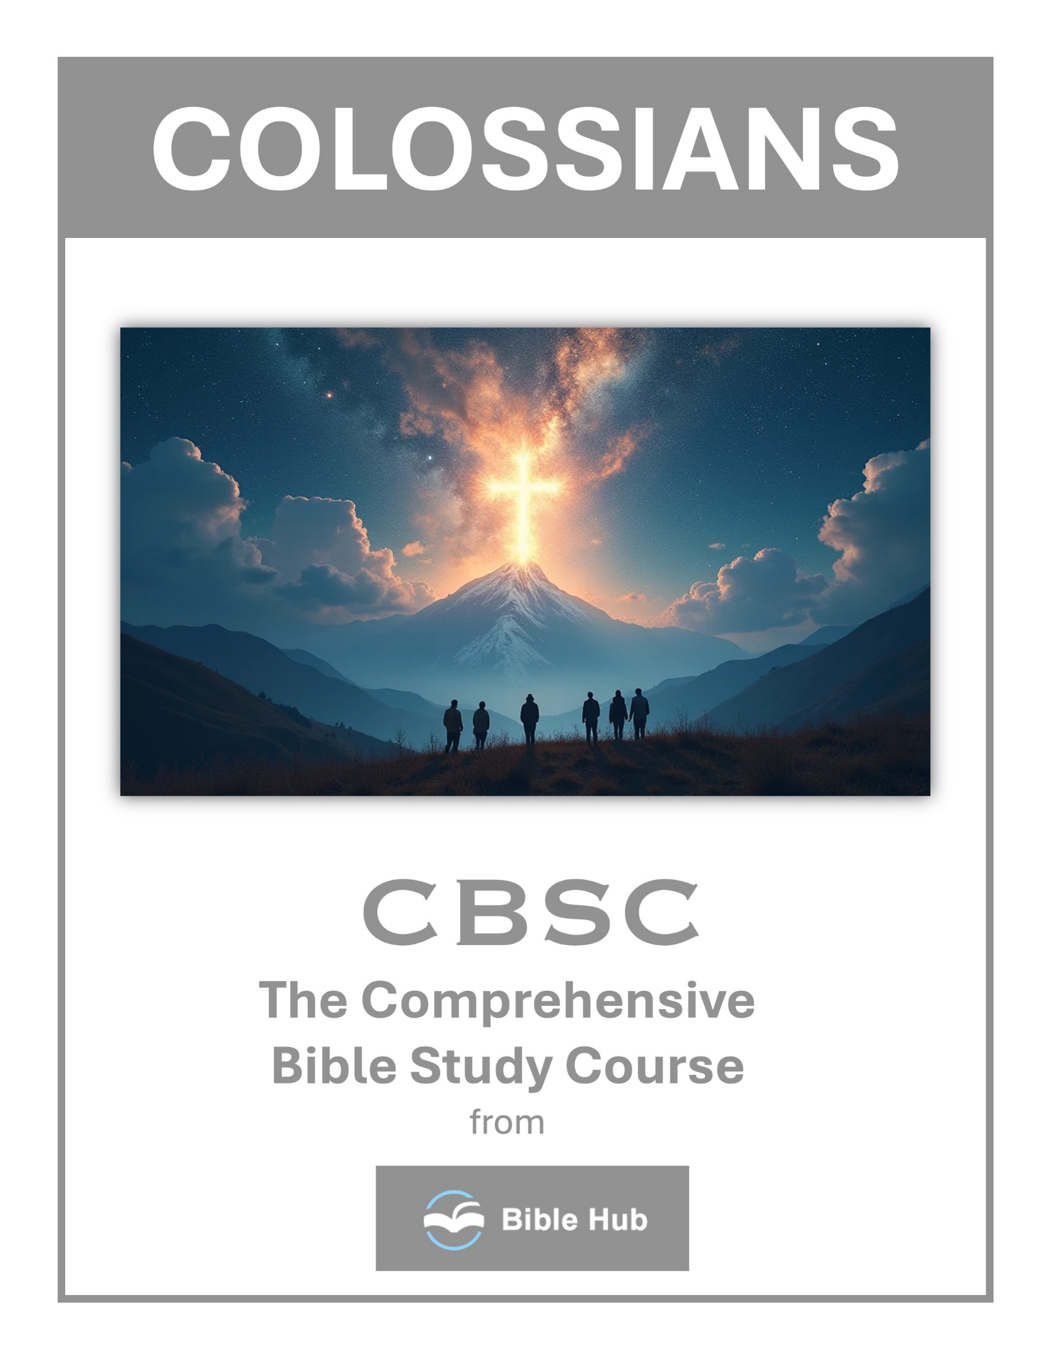

Colossians 1 Teaching Points and Bible Study Questions
The Supremacy of Christ
In Colossians 1:15, we learn that "He is the image of the invisible God, the firstborn over all creation." This verse reminds us of Christ's preeminence and His divine nature. Recognizing Christ's supremacy in our lives helps us prioritize our relationship with Him, ensuring that our daily actions reflect His teachings and love.
1. How can recognizing Christ's supremacy influence your daily decision-making and priorities?
2. Why do you think acknowledging Christ's authority can transform your relationships with others?
3. What practical steps can you take to reflect Christ's preeminence in your work or community?
The Creator of All Things
Colossians 1:16 states, "For in Him all things were created, things in heaven and on earth, visible and invisible." This powerful truth encourages us to see the world through the lens of God's creation, appreciating the beauty and complexity of life. It also inspires us to steward the earth responsibly, honoring the Creator in all we do.
1. How can recognizing Christ as Creator influence your daily decisions and interactions with others?
2. Why do you think acknowledging Christ's role in creation can strengthen your faith?
3. What practical steps can you take to honor Christ as Creator in your environment?

Christ Holds Everything Together
Verse 17 tells us, "He is before all things, and in Him all things hold together." This assurance provides comfort and stability in our lives, reminding us that no matter how chaotic things may seem, Christ is the glue that holds everything in place. Trusting in His sovereignty allows us to face challenges with peace and confidence.
1. How can you rely on Christ to hold your life together during challenging times?
2. Why do you think recognizing Christ's role in creation impacts your daily decisions?
3. What practical steps can you take to acknowledge Christ's presence in your everyday activities?
The Head of the Church
Colossians 1:18 declares, "And He is the head of the body, the church." Understanding Christ's role as the head of the church encourages us to align our actions and decisions with His will. It also emphasizes the importance of community and fellowship, as we are all parts of His body, working together to fulfill His mission.
1. How can you practically acknowledge Christ as the head of your daily life and decisions?
2. Why do you think recognizing Christ as the head strengthens church unity and purpose?
3. What can you do to ensure Christ's leadership is evident in your community interactions?

Reconciliation Through Christ
In verse 20, we read, "and through Him to reconcile to Himself all things, whether things on earth or things in heaven, by making peace through His blood, shed on the cross." This profound truth highlights the power of Christ's sacrifice, offering us reconciliation with God. Embracing this reconciliation transforms our lives, filling us with gratitude and a desire to share His love with others.
1. How can you actively pursue reconciliation in your relationships, inspired by Christ's example in Colossians 1?
2. Why do you think reconciliation through Christ is essential for personal and communal peace?
3. What steps can you take to embody Christ's reconciling love in your daily interactions?
The Mystery of the Gospel
Colossians 1:26-27 speaks of "the mystery that was hidden for ages and generations but is now revealed to His saints." This mystery, which is Christ in us, the hope of glory, is a treasure that we are called to share. Understanding this mystery fuels our passion for evangelism, as we invite others to experience the hope and joy found in Christ.
1. How can you apply the mystery of the Gospel in your daily interactions with others?
2. Why do you think understanding the Gospel's mystery is crucial for personal spiritual growth?
3. What steps can you take to reveal the Gospel's mystery to those around you?

Strengthened with All Power
Verse 11 encourages us to be "strengthened with all power according to His glorious might." This divine strength equips us to endure life's trials with patience and joy. By relying on God's power, we can overcome obstacles and live victoriously, reflecting His glory in our daily lives.
1. How can you apply being "strengthened with all power" in your daily challenges and decisions?
2. Why do you think spiritual strength is essential for enduring life's difficulties with patience and joy?
3. What can you do to cultivate a mindset that seeks divine strength over personal ability?
Qualified to Share in the Inheritance
Colossians 1:12 reminds us to give "thanks to the Father, who has qualified you to share in the inheritance of the saints in the light." This inheritance is a gift of grace, not something we earn. Recognizing our qualification through Christ fills us with gratitude and motivates us to live as heirs of His kingdom, shining His light in the world.
1. How can you actively live as someone qualified to share in God's inheritance daily?
2. Why do you think gratitude is essential in recognizing our qualification for God's inheritance?
3. What steps can you take to better understand and embrace your spiritual inheritance?

Delivered from Darkness
Verse 13 proclaims, "He has rescued us from the dominion of darkness and brought us into the kingdom of His beloved Son." This deliverance is a powerful reminder of the transformation we experience in Christ. Embracing our new identity empowers us to leave behind the darkness of sin and walk in the light of His love.
1. How can you actively live out being delivered from darkness in your daily life?
2. What do you hope to change in your life by embracing the light of Christ?
3. Why do you think recognizing our deliverance from darkness is crucial for spiritual growth?
The Hope of the Gospel
Finally, Colossians 1:23 urges us to "continue in your faith, established and firm, not moved from the hope of the gospel." This hope anchors our souls, providing stability and direction. By holding fast to the gospel, we remain steadfast in our faith, ready to face whatever comes our way with courage and conviction.
1. How can you actively share the hope of the Gospel in your daily interactions?
2. What do you hope to change in your life by embracing the Gospel's promises?
3. Why does the hope of the Gospel motivate you to persevere through challenges?

Colossians 2 Teaching Points and Bible Study Questions
Rooted in Christ
In Colossians 2:6-7, Paul encourages believers to "continue to live in Him, rooted and built up in Him, established in the faith as you were taught, and overflowing with thankfulness." This is a call to deepen our relationship with Christ, ensuring that our lives are firmly anchored in His teachings. Just as a tree draws strength from its roots, we draw spiritual strength from our connection with Jesus. This foundation not only stabilizes us but also allows us to grow and flourish in our faith journey.
1. How can you ensure your daily actions reflect being rooted in Christ's teachings?
2. Why do you think being rooted in Christ helps resist worldly pressures?
3. What practical steps can you take to deepen your spiritual roots in Christ?
Beware of Deceptive Philosophy
Paul warns in Colossians 2:8, "See to it that no one takes you captive through philosophy and empty deception, according to the tradition of men, according to the basic principles of the world, rather than Christ." This is a reminder to be vigilant against worldly ideologies that can lead us astray. By holding fast to the truth of Scripture, we can discern and reject teachings that contradict the gospel, ensuring that our minds and hearts remain aligned with God's wisdom.
1. How can you identify and avoid deceptive philosophies in your daily life?
2. Why do you think deceptive philosophies are appealing, and how can you resist them?
3. What practical steps can you take to strengthen your faith against misleading teachings?

Fullness in Christ
Colossians 2:9-10 declares, "For in Christ all the fullness of the Deity dwells in bodily form. And you have been made complete in Christ, who is the head over every ruler and authority." This profound truth assures us that in Christ, we lack nothing. He is the source of all spiritual blessings, and through Him, we are made whole. Embracing this completeness empowers us to live confidently, knowing that our identity and purpose are secure in Him.
1. How can you experience the fullness of Christ in your daily life and decisions?
2. Why do you think understanding Christ's fullness impacts your sense of identity and purpose?
3. What practical steps can you take to rely on Christ's fullness rather than worldly philosophies?
Spiritual Circumcision
In Colossians 2:11, Paul speaks of a "circumcision made without hands, in the removal of the body of the flesh by the circumcision of Christ." This metaphorical circumcision signifies the cutting away of our sinful nature, a transformation that occurs when we accept Christ. It's a powerful reminder that our old selves have been put to death, and we are now new creations, called to live in righteousness and holiness.
1. How can understanding spiritual circumcision influence your daily decisions and actions as a believer?
2. Why do you think spiritual circumcision is essential for personal growth in your faith journey?
3. What practical steps can you take to embrace the concept of spiritual circumcision in your life?

Buried and Raised with Him
Colossians 2:12 highlights the significance of baptism: "having been buried with Him in baptism, in which you were also raised with Him through your faith in the power of God, who raised Him from the dead." Baptism symbolizes our union with Christ in His death and resurrection. It is a public declaration of our faith and a testament to the new life we have received through His victory over sin and death.
1. How can being "buried and raised with Him" influence your daily decision-making and priorities?
2. What do you hope to change in your life by embracing the concept of being raised with Christ?
3. Why does understanding your spiritual resurrection with Christ matter in overcoming personal challenges?
Forgiven and Free
Paul proclaims in Colossians 2:13-14, "When you were dead in your trespasses and in the uncircumcision of your flesh, God made you alive with Christ. He forgave us all our trespasses, having canceled the debt ascribed to us in the decrees that stood against us." This is the heart of the gospel: through Christ's sacrifice, our sins are forgiven, and the debt we owed has been erased. We are liberated from the bondage of sin, free to live in the light of His grace.
1. How can understanding your forgiveness in Christ change your daily interactions with others?
2. What do you hope to experience by embracing the freedom found in Christ's forgiveness?
3. Why does recognizing your freedom in Christ impact your response to guilt and shame?

Triumph Over Evil
Colossians 2:15 reveals the victory of Christ: "And having disarmed the powers and authorities, He made a public spectacle of them, triumphing over them by the cross." Jesus' death and resurrection defeated the forces of darkness, stripping them of their power. This victory assures us that we are not fighting for victory but from victory. We can face spiritual battles with confidence, knowing that Christ has already won the ultimate war.
1. How can you apply Christ's triumph over evil in your daily struggles and challenges?
2. Why do you think understanding Christ's victory helps in resisting temptation and negative influences?
3. What practical steps can you take to live confidently in the freedom Christ provides from evil?
Freedom from Legalism
In Colossians 2:16-17, Paul advises, "Therefore let no one judge you by what you eat or drink, or with regard to a feast, a New Moon, or a Sabbath. These are a shadow of the things to come, but the reality is found in Christ." This passage liberates us from the constraints of legalistic practices, emphasizing that our faith is not about adhering to rituals but about a relationship with Christ. He is the substance, and our focus should be on Him.
1. How can you identify and resist legalistic practices in your daily spiritual life?
2. Why do you think freedom from legalism is essential for authentic faith?
3. What practical steps can you take to prioritize grace over legalistic rules?

Holding Fast to the Head
Colossians 2:19 encourages us to "hold fast to the Head, from whom the whole body, supported and knit together by its ligaments and sinews, grows with a growth that is from God." Christ is the head of the Church, and our connection to Him is vital for spiritual growth. By staying united with Him, we receive nourishment and strength, enabling us to mature in our faith and fulfill our God-given purpose.
1. How can you practically hold fast to Christ in your daily life and decisions?
2. Why do you think staying connected to Christ is essential for spiritual growth?
3. What can you do to ensure Christ remains the central focus in your community?
Set Free from Human Regulations
Finally, Colossians 2:20-23 reminds us that we have died with Christ to the "elemental spiritual forces of the world." We are no longer bound by human regulations that promise wisdom but lack true value. Our focus should be on living in the freedom Christ provides, guided by His Spirit and truth. This freedom empowers us to pursue a life that honors God, unencumbered by the constraints of man-made rules.
1. How can you identify and resist human regulations that conflict with your faith in daily life?
2. Why do you think relying on Christ's teachings offers more freedom than following human traditions?
3. What practical steps can you take to prioritize spiritual growth over adhering to human-made rules?

Colossians 3 Teaching Points and Bible Study Questions
Set Your Minds on Things Above
In Colossians 3:2, we are encouraged to "Set your minds on things above, not on earthly things." This is a call to focus on the eternal rather than the temporary. By prioritizing heavenly values, we align our daily actions with God's purpose, leading to a more fulfilling and purposeful life. This mindset shift can transform how we approach challenges, reminding us that our ultimate goal is to glorify God in all we do.
1. How can you daily set your mind on things above in a busy world?
2. What practical steps help you focus on eternal values over temporary concerns?
3. Why do you think setting your mind on heavenly things impacts your daily decisions?
Put to Death Earthly Nature
Colossians 3:5 instructs us to "Put to death, therefore, the components of your earthly nature." This means actively rejecting behaviors and desires that pull us away from God. By doing so, we create space for spiritual growth and allow the Holy Spirit to work more effectively in our lives. It's about making conscious choices that reflect our commitment to living a life that honors God.
1. How can you identify and put to death earthly desires in your daily life?
2. Why do you think it's challenging to let go of earthly nature, and how can you overcome it?
3. What practical steps can you take to replace earthly habits with spiritual virtues?

Clothe Yourself with Compassion
Verse 12 of Colossians 3 tells us to "clothe yourselves with compassion, kindness, humility, gentleness, and patience." These virtues are not just nice-to-haves; they are essential for building strong, loving relationships. By embodying these qualities, we reflect Christ's love to those around us, creating a ripple effect of positivity and grace in our communities.
1. How can you practically show compassion in your daily interactions with others this week?
2. Why do you think compassion is essential for building strong relationships within your community?
3. What steps can you take to cultivate a more compassionate mindset in challenging situations?
Forgive as the Lord Forgave You
Forgiveness is a powerful theme in Colossians 3:13, which says, "Forgive as the Lord forgave you." Holding onto grudges can weigh us down, but when we choose to forgive, we experience freedom and peace. Remembering how much we have been forgiven by God can inspire us to extend that same grace to others, fostering healing and reconciliation.
1. How can you practice forgiveness in daily conflicts, reflecting the Lord's forgiveness towards you?
2. Why do you think forgiving others can be challenging, and how can you overcome these challenges?
3. What steps can you take to cultivate a forgiving heart in your relationships?

Let the Peace of Christ Rule in Your Hearts
In verse 15, we are reminded to "Let the peace of Christ rule in your hearts." This peace is not just the absence of conflict but a deep, abiding sense of well-being that comes from trusting in God's sovereignty. By allowing Christ's peace to guide our decisions and interactions, we can navigate life's ups and downs with confidence and calm.
1. How can you actively let the peace of Christ rule in your daily decision-making?
2. Why do you think maintaining Christ's peace is essential in resolving conflicts with others?
3. What practical steps can you take to cultivate a heart ruled by Christ's peace?
Be Thankful
Colossians 3:15 also encourages us to "be thankful." Gratitude is a powerful tool for shifting our perspective and enhancing our well-being. By regularly counting our blessings and expressing thanks, we cultivate a positive outlook that can transform our daily experiences and deepen our relationship with God.
1. How can you incorporate gratitude into your daily routine based on Colossians 3:15-17?
2. Why do you think thankfulness is emphasized in fostering peace and unity in relationships?
3. What practical steps can you take to express gratitude in challenging situations?

Let the Word of Christ Dwell Richly
Verse 16 urges us to "Let the word of Christ dwell in you richly." Immersing ourselves in Scripture equips us with wisdom and guidance for every situation. By making Bible study a regular part of our routine, we allow God's truth to shape our thoughts and actions, leading to a more Christ-centered life.
1. How can you incorporate the Word of Christ into your daily routine to enrich your life?
2. Why do you think letting the Word dwell richly impacts your relationships with others?
3. What practical steps can you take to ensure the Word of Christ influences your decisions?
Teach and Admonish One Another
Colossians 3:16 also highlights the importance of community: "Teach and admonish one another with all wisdom." We are called to support and encourage each other in our faith journeys. By sharing insights and holding each other accountable, we grow stronger together, building a community that reflects God's love and truth.
1. How can you effectively teach and admonish others in your community with love and wisdom?
2. What practical steps can you take to ensure your teaching aligns with Christ's message?
3. Why do you think mutual teaching and admonishing are vital for spiritual growth in a community?

Do Everything in the Name of the Lord Jesus
Verse 17 challenges us to "do everything in the name of the Lord Jesus." This means that every action, no matter how small, should be done with the intention of honoring God. By keeping this perspective, we infuse our daily tasks with purpose and meaning, transforming the mundane into acts of worship.
1. How can you ensure your daily actions reflect doing everything in the name of the Lord Jesus?
2. Why do you think it's important to seek Jesus' guidance in all aspects of your life?
3. What changes would you make to align your work and relationships with the teachings of Jesus?
Love Binds Everything Together
Finally, Colossians 3:14 reminds us that "love binds everything together in perfect unity." Love is the foundation of all the virtues mentioned in this chapter. It is the glue that holds our relationships and communities together. By prioritizing love in all we do, we reflect the heart of Christ and create a harmonious environment where everyone can thrive.
1. How can you practice love to strengthen relationships in your daily life?
2. Why do you think love is essential for unity in a community?
3. What can you do to ensure love guides your actions and decisions?

Colossians 4 Teaching Points and Bible Study Questions
Devote Yourself to Prayer
Prayer is the lifeline of a believer, a direct line to our Creator. Colossians 4:2 encourages us to "Devote yourselves to prayer, being watchful and thankful." This isn't just a suggestion; it's a call to action. Prayer keeps us connected to God, aligns our hearts with His will, and opens our eyes to His work in our lives. Make prayer a priority, and watch how it transforms your day-to-day experiences.
1. How can you incorporate prayer into your daily routine to stay spiritually connected?
2. What do you hope to achieve by devoting more time to prayer in your life?
3. Why do you think consistent prayer is essential for personal and communal spiritual growth?
Be Watchful and Thankful
In the same verse, we're reminded to be watchful and thankful. Being watchful means staying alert to the spiritual realities around us, recognizing both the challenges and the blessings. Thankfulness shifts our focus from what we lack to what we have, fostering a spirit of gratitude. This combination of vigilance and gratitude equips us to navigate life's ups and downs with grace and wisdom.
1. How can you incorporate watchfulness and thankfulness into your daily routine effectively?
2. Why do you think being watchful enhances your ability to be thankful in challenging situations?
3. What practical steps can you take to remain thankful even when life feels overwhelming?

Pray for Open Doors
Paul, in Colossians 4:3, asks for prayers that "God may open to us a door for the word, to declare the mystery of Christ." This is a powerful reminder to seek opportunities to share the Gospel. Pray for open doors in your own life, whether it's a conversation with a neighbor or a chance to serve in your community. God is always at work, and He invites us to join Him in His mission.
1. How can you actively seek opportunities to share your faith in daily life?
2. Why do you think prayer is essential for recognizing open doors for ministry?
3. What steps can you take to prepare for unexpected opportunities to share the gospel?
Speak with Clarity
When those doors open, clarity is key. Colossians 4:4 says, "Pray that I may proclaim it clearly, as I should." Clear communication of the Gospel is essential. Whether you're sharing your testimony or explaining a biblical truth, aim for simplicity and sincerity. The message of Christ is profound yet accessible, and our words should reflect that.
1. How can you ensure your speech is clear and gracious in daily conversations with others?
2. Why do you think clarity in communication is important for sharing your faith effectively?
3. What practical steps can you take to improve clarity in your speech at work or home?

Walk in Wisdom
"Walk in wisdom toward outsiders, making the most of every opportunity," Paul advises in Colossians 4:5. Wisdom is more than knowledge; it's the application of God's truth in our daily lives. As we interact with those who may not share our faith, wisdom guides our actions and words, ensuring they reflect Christ's love and truth.
1. How can you apply walking in wisdom to your daily interactions with non-believers?
2. What practical steps can you take to make your speech gracious and seasoned with salt?
3. Why do you think walking in wisdom is essential for effective Christian witness?
Season Your Speech with Grace
Colossians 4:6 encourages us to let our conversation be "always full of grace, seasoned with salt." Grace-filled speech is kind, respectful, and uplifting. It's about speaking truth in love and being mindful of how our words affect others. Just as salt enhances flavor, our words should enhance and enrich the lives of those we encounter.
1. How can you ensure your daily conversations reflect grace and kindness towards others?
2. Why do you think it's important to season your speech with grace in challenging situations?
3. What practical steps can you take to improve the way you communicate with others?

Be a Faithful Messenger
Paul mentions several faithful messengers in Colossians 4, like Tychicus and Onesimus, who were entrusted with delivering his letters. Their example reminds us of the importance of being reliable and trustworthy in our own roles. Whether you're sharing a message, fulfilling a task, or supporting a friend, faithfulness is a testament to your character and commitment to Christ.
1. How can you ensure your message aligns with your faith when communicating with others?
2. Why do you think being a faithful messenger is important in your daily interactions?
3. What practical steps can you take to be more consistent in sharing your faith?
Encourage and Support Fellow Believers
In Colossians 4:11, Paul speaks of those who have been a comfort to him. Encouragement and support are vital within the body of Christ. We are called to lift each other up, offering comfort and strength in times of need. A simple word of encouragement can have a profound impact, reminding others of God's love and faithfulness.
1. How can you practically encourage fellow believers in their faith journey this week?
2. Why do you think supporting others is essential for a strong faith community?
3. What can you do to offer meaningful support to a struggling believer today?

Remember the Power of Community
Paul's closing greetings in Colossians 4 highlight the importance of community. He mentions various individuals by name, showing the interconnectedness of the early church. We, too, are part of a larger community of believers. Engage with your church family, participate in small groups, and build relationships that foster spiritual growth and accountability.
1. How can you actively contribute to building a supportive community within your church or group?
2. Why do you think Paul emphasizes the importance of community in his final greetings?
3. What can you do to strengthen relationships and encourage others in your community this week?
Fulfill Your Ministry
Finally, Paul urges Archippus in Colossians 4:17 to "See to it that you complete the ministry you have received in the Lord." Each of us has a unique calling and purpose. Whether it's teaching, serving, or leading, fulfill your ministry with diligence and passion. God has equipped you for a specific role in His kingdom, and your faithful service brings glory to Him.
1. How can you actively support others in fulfilling their ministry within your community?
2. What steps can you take to ensure you fulfill your ministry effectively?
3. Why do you think it's important to stay devoted to prayer in fulfilling your ministry?

